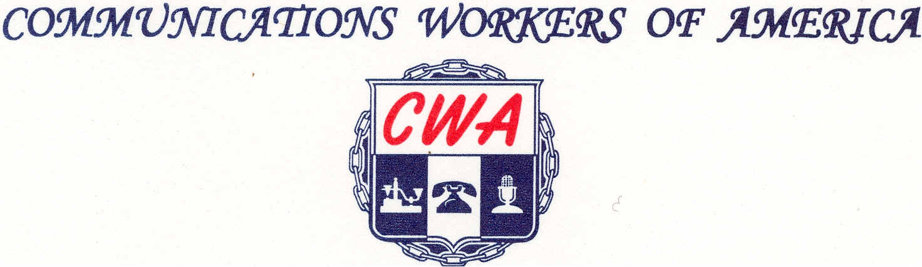
LOCAL 6372
MISSOURI / KANSAS
(Affiliated with AFL-ClO)

Lifetime Union Member Discount
Value: 27% OFF
Local: CWA 6372
Union Discount Code: Cw6372mD
Get 27% OFF our suggested retail price on any American-Made,

Union-Made, work boot we sell at
www.TheUnionBootPro
We feature Thorogood, WorkOne and HellFire footwear
MADE IN USA
Weinbrenner Shoe Company - one of America's oldest
Manufacturers of quality constructed, job-fitted safety work boots



