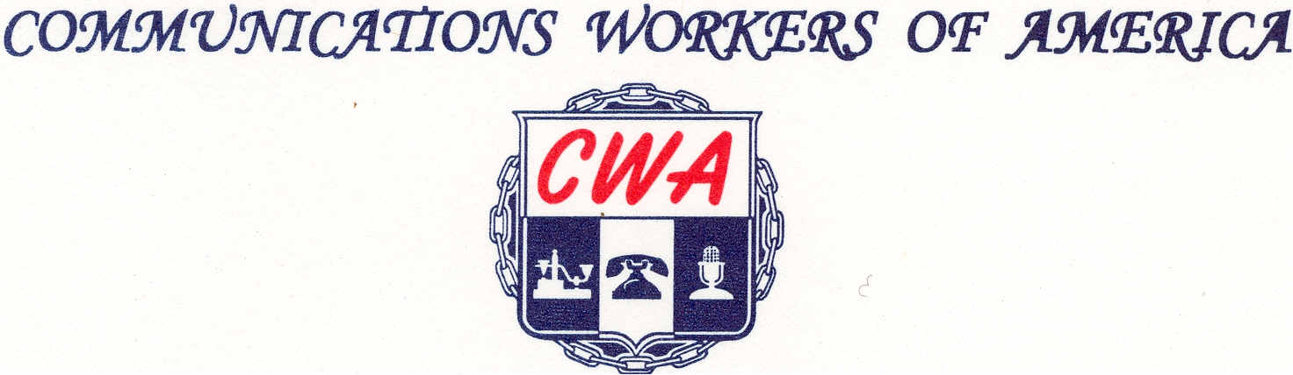
LOCAL 6372
MISSOURI / KANSAS
(Affiliated with AFL-ClO)

Retirement Notice
Date_______________
Name of Retiree___________________________________________________
Address of Retiree_________________________________________________
Name of Local Steward_____________________________________________
Retiree Phone Number_______________________________________
Do you wish to receive information about?
Ring_________
Watch_________
Gold Card_________
Retired Members Counsel___________
Send this form to the Local Secretary at cwa6372@Gmail.com
Per the local Stand Operating Procedure as of 10-5-2017 you get a total of $400 to be spent and way the retiree chooses. After you spend $400 you must get with complete a CWA official Expense Voucher. A copy of the Voucher and all Receipts totaling $400 should be sent to the local President at preslocal6372@gmail.com for approval and Payout.


